**Assignment 2: Radius and Windows Services**

**Assignment Summary:**

In this assignment, I expanded the BeesKnees Inc. network by integrating a new Windows server to take over VPN responsibilities from the domain controller. I configured this server with dual NICs for external and internal connectivity and set up RRAS using RADIUS authentication via NPS hosted on the domain controller. The VPN access was restricted to specific domain users (Erica and Simon), and I ensured the external client could securely connect, browse shared files, and access internal web services through port forwarding. A publicly readable FTP site and SSL-secured websites (www and staff subdomains) were also deployed using IIS, with appropriate DNS and host entries configured to simulate real-world access scenarios.

Through this project, I deepened my understanding of VPN deployment, RADIUS authentication, secure web hosting on Windows Server, and the integration of access controls based on user roles. I also gained practical experience with port forwarding, SSL configuration, and DNS management in a hybrid internal-external network. A key challenge was ensuring accurate routing and firewall configurations for secure access, which I resolved through careful troubleshooting and validation of connectivity between internal and external clients.

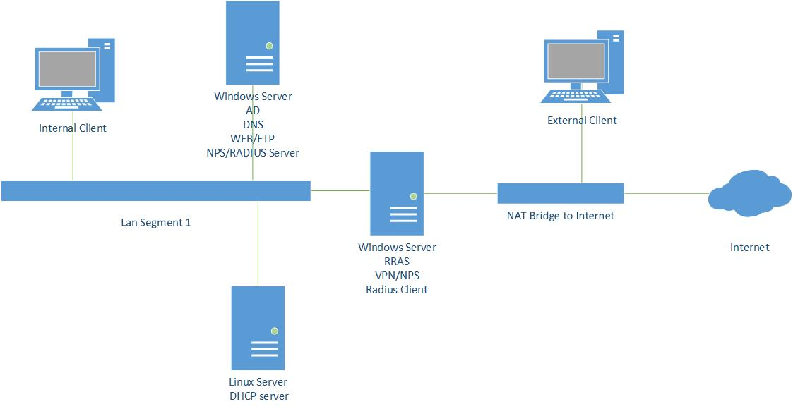

**Screenshots :**

**Windows server**

Updated contents of the DNS forward lookup zone

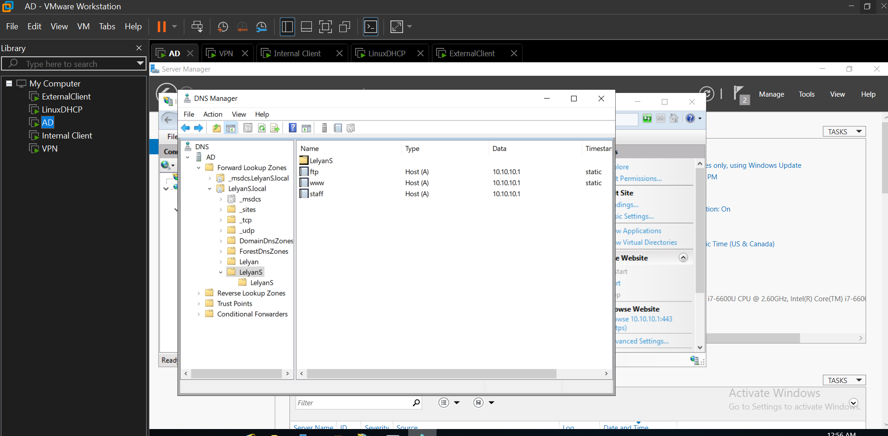

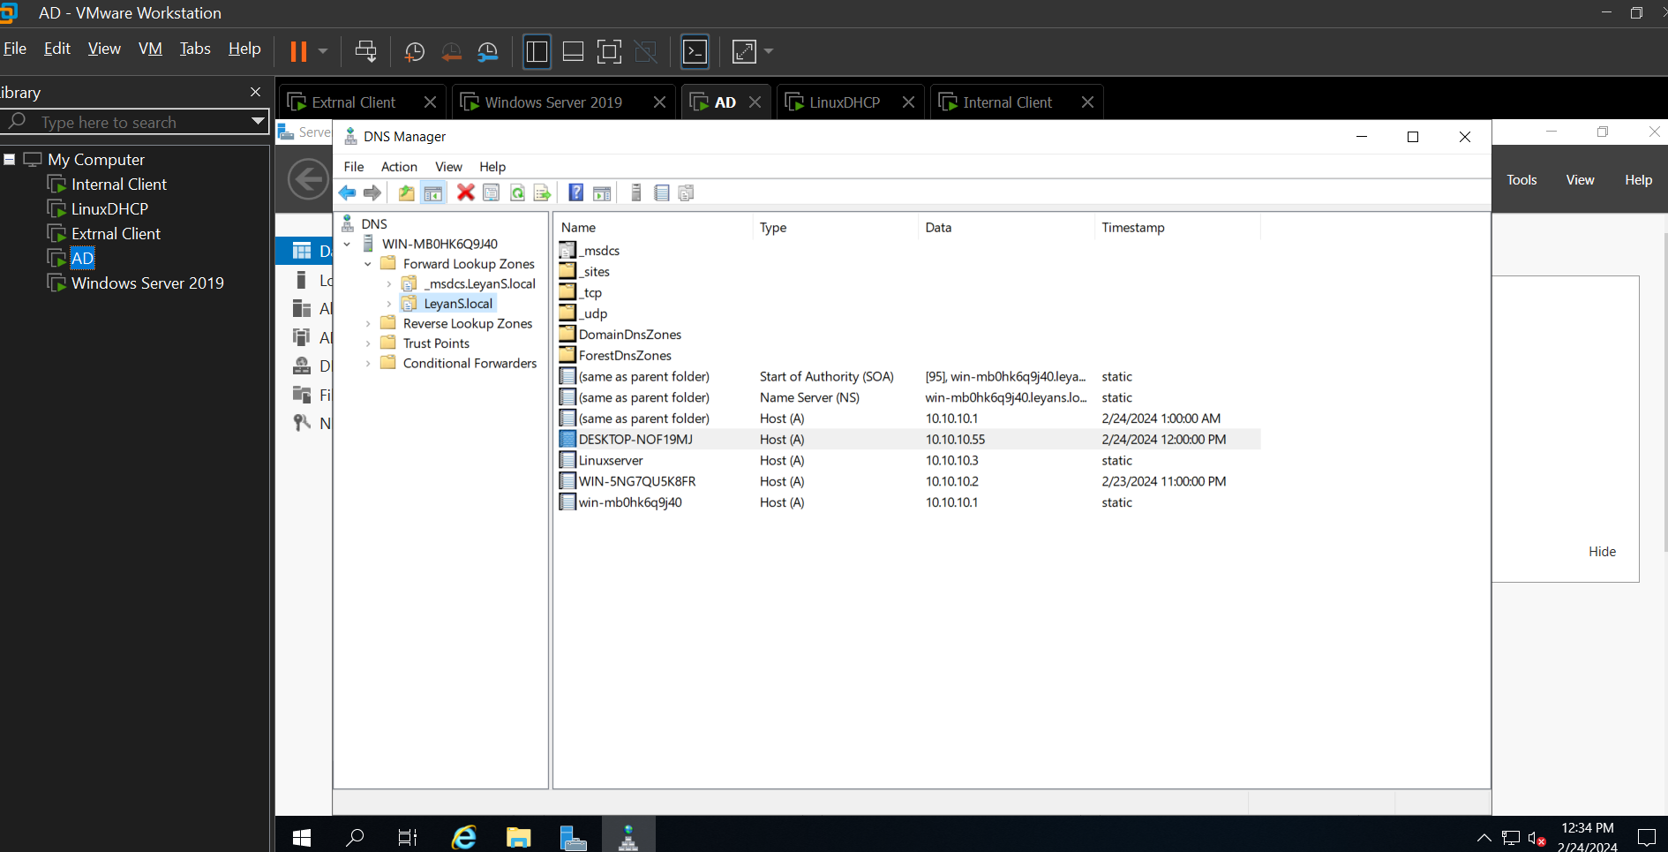

NPS configuration showing the contents of the radius client, the active network policy, and the connection requests policy.

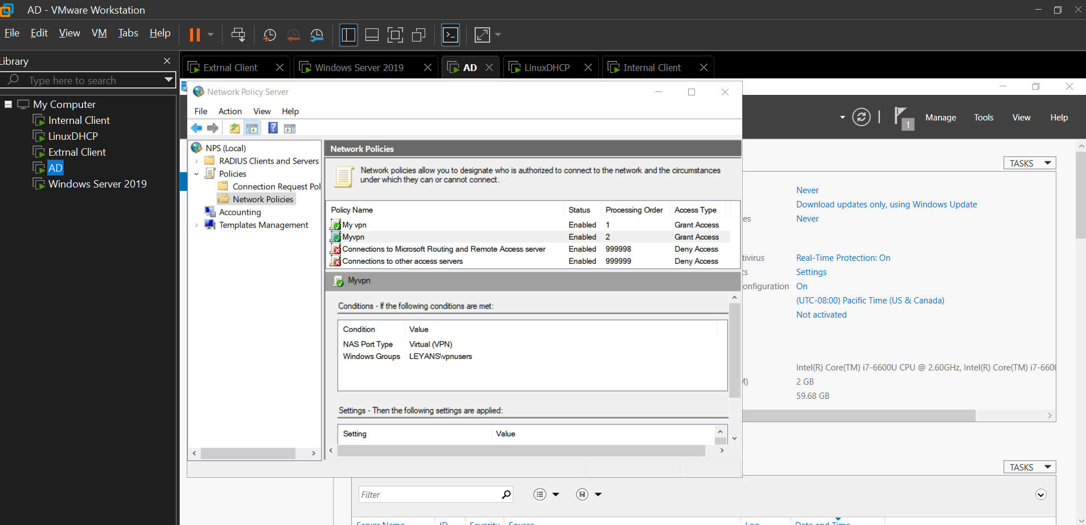

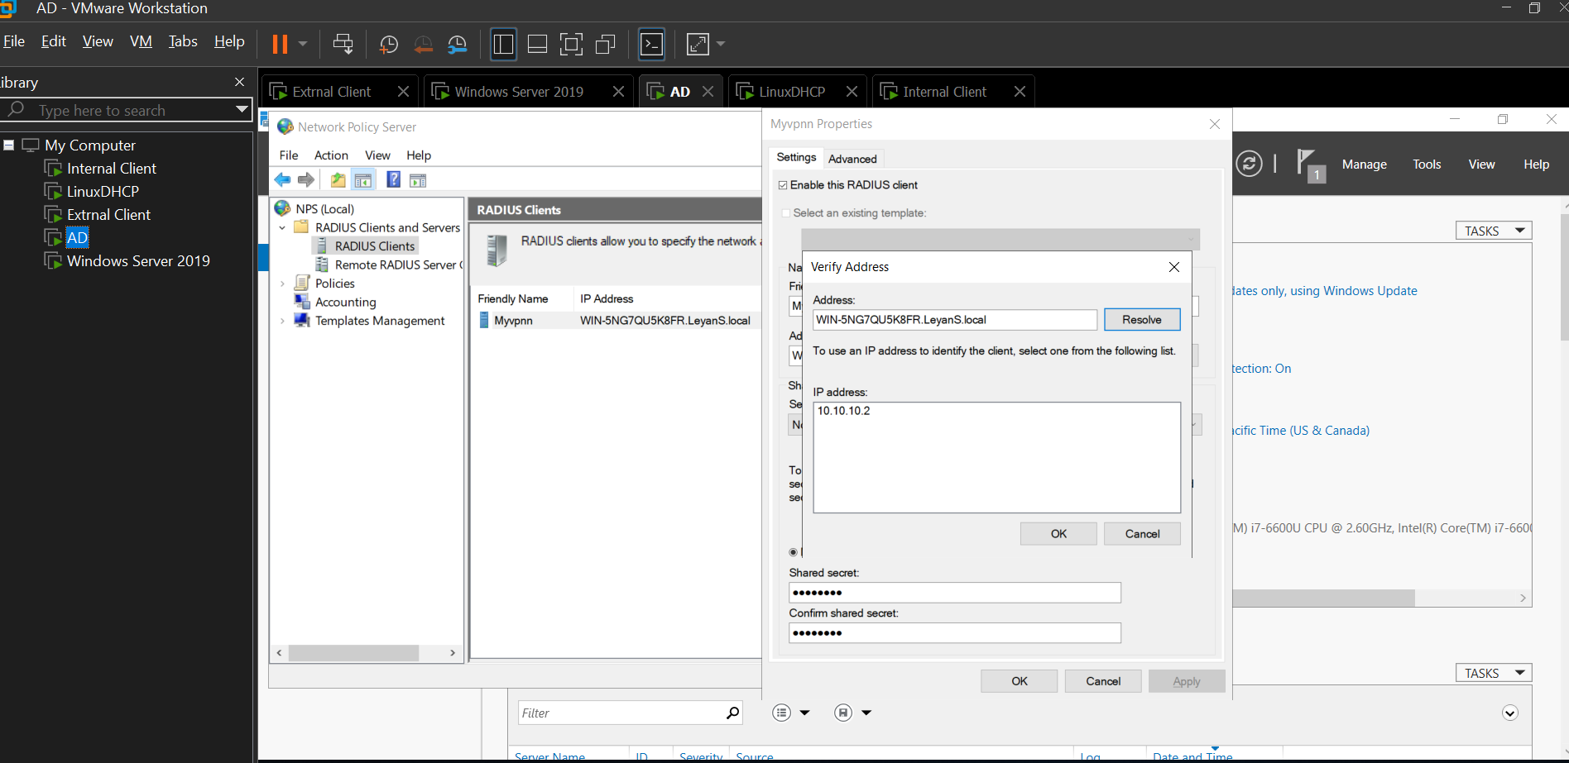

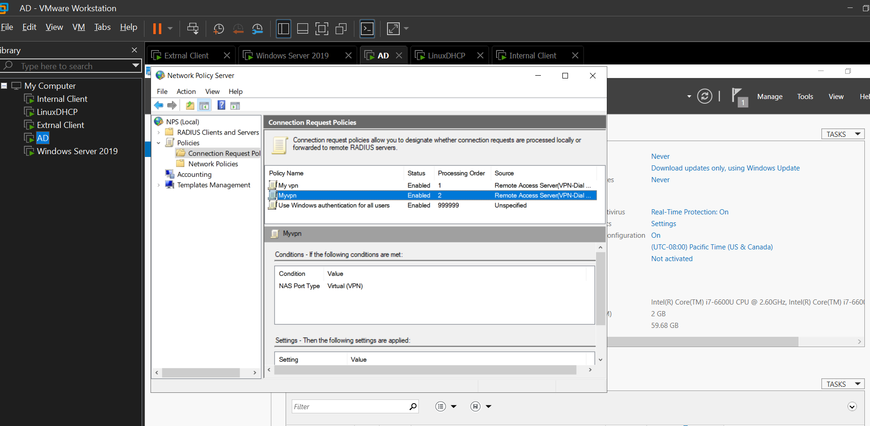

IIS showing the created FTP and Websites

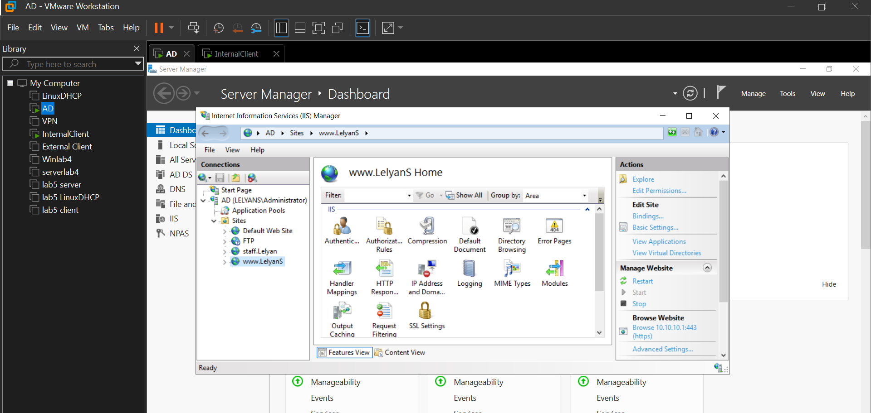

Show how permissions were set on the FTP site

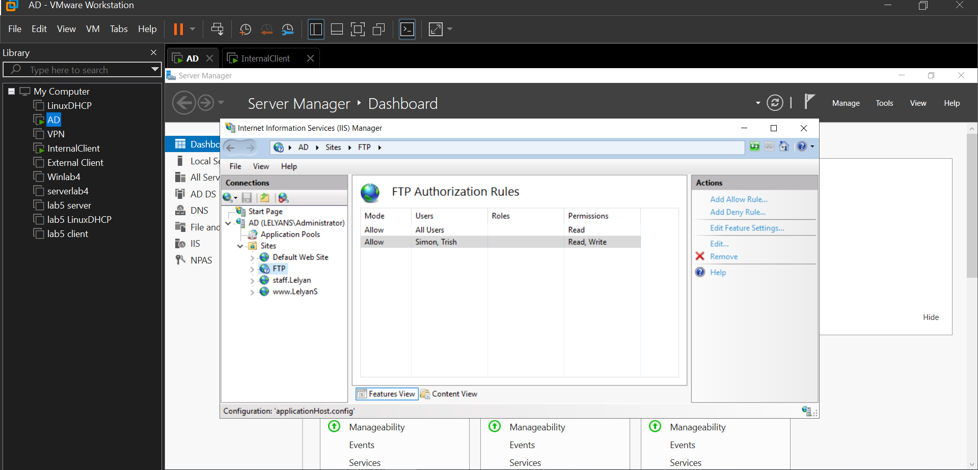

**VPN Server**

Security tab of RRAS properties, showing the configure… for RADIUS authentication and accounting

Show port forwarding configuration

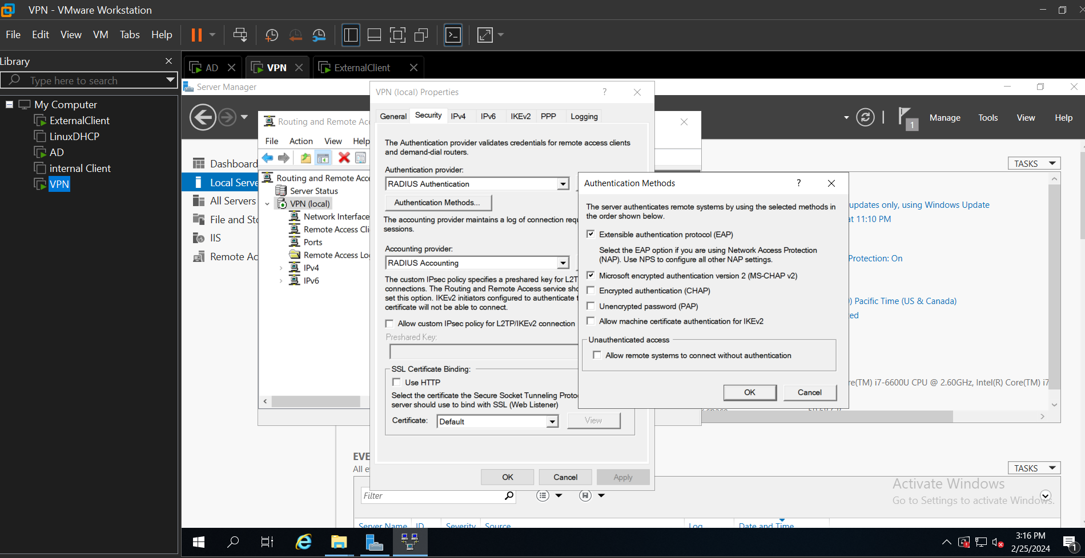

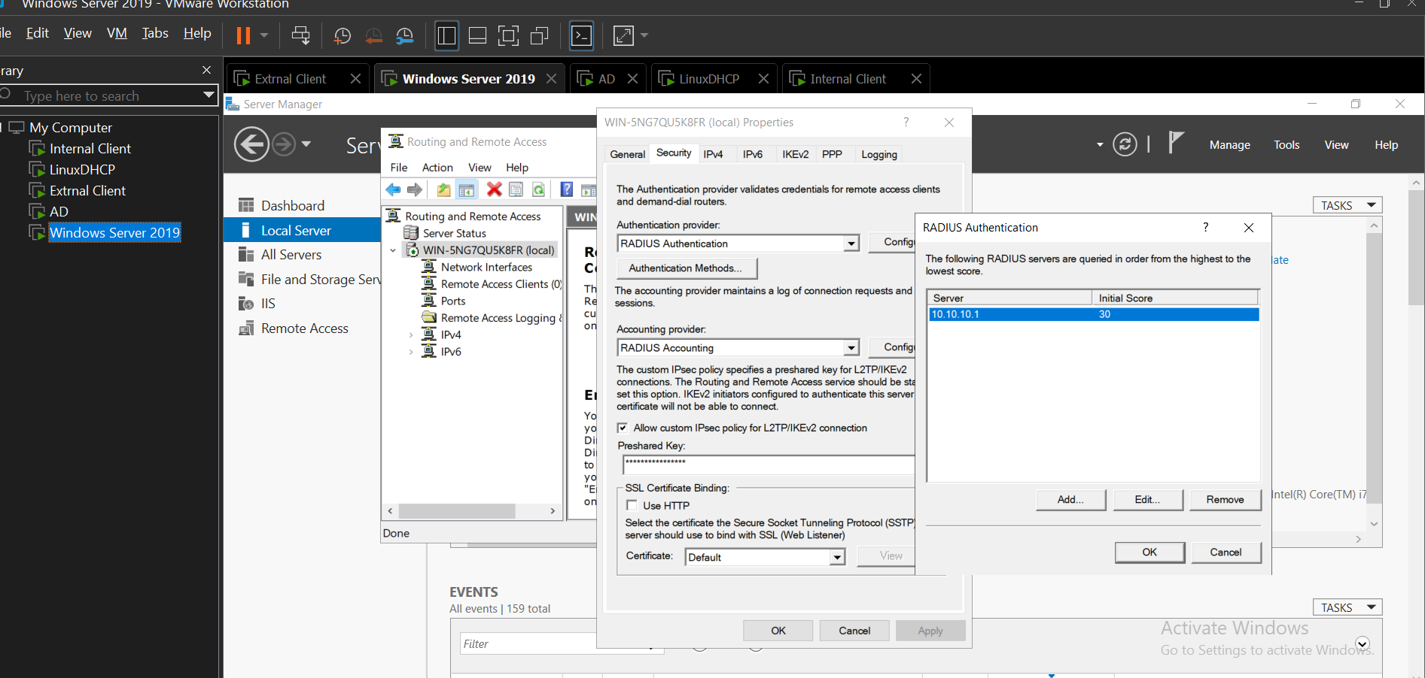

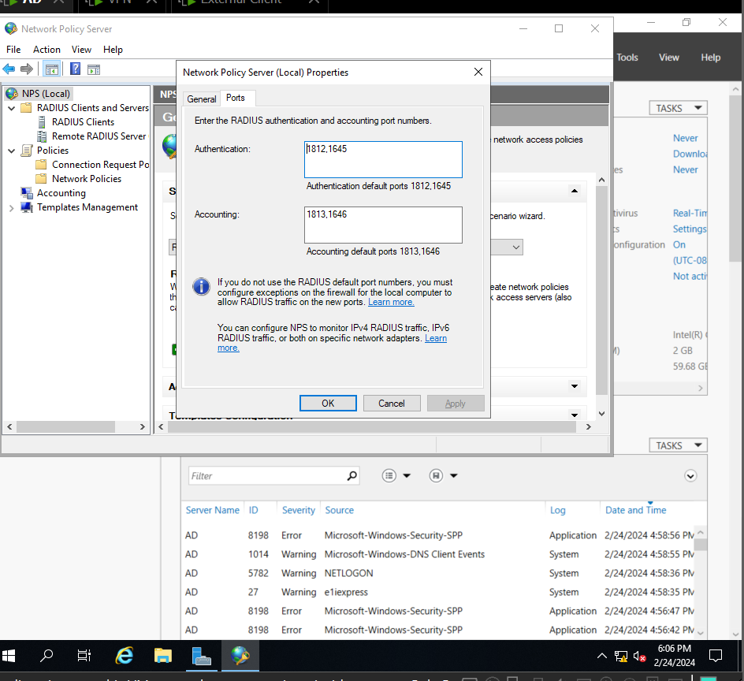

**Linux server**

New DHCP scope configuration with changes to network reflected

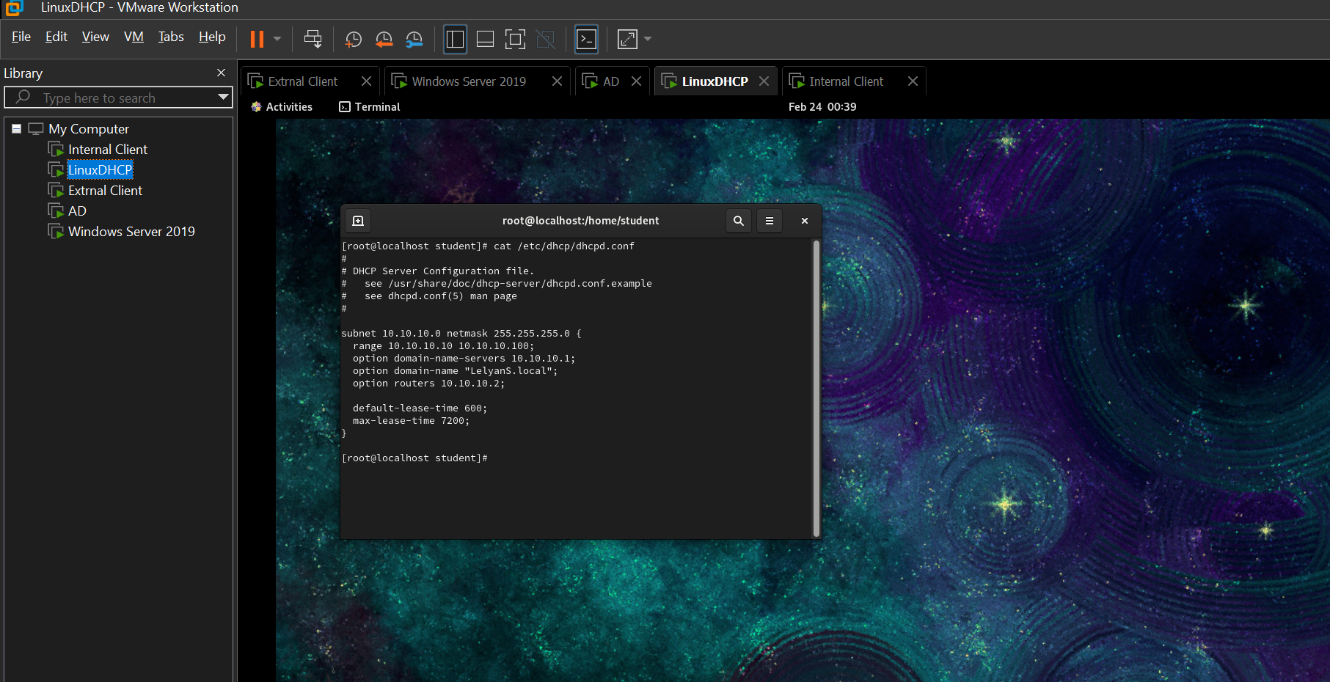

**Internal Client**

==When logged in as Erica==

Ipconfig /all output

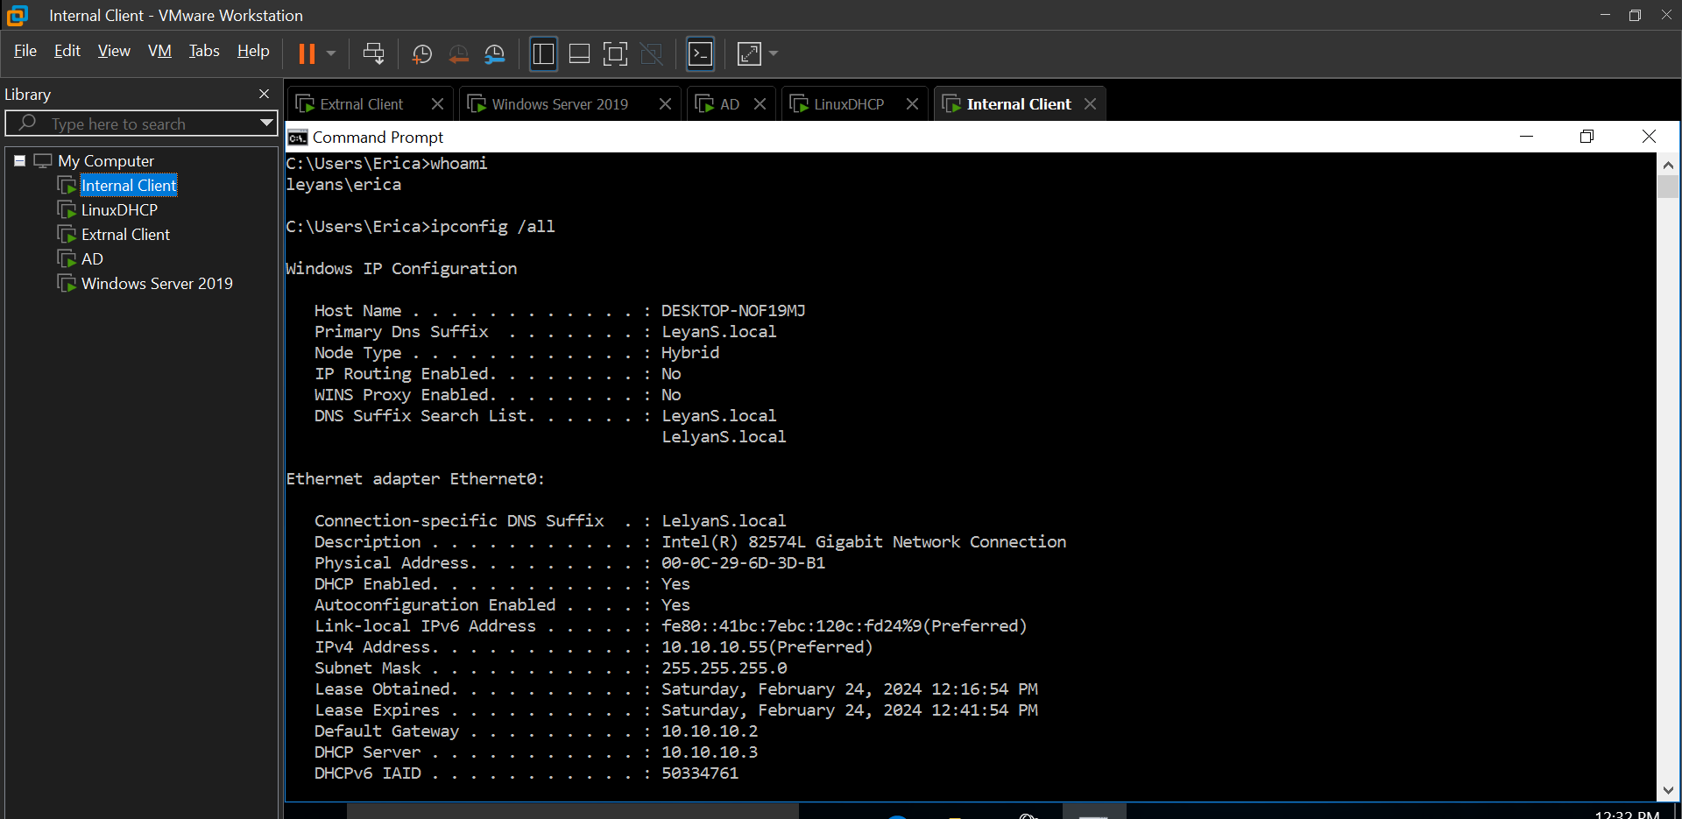

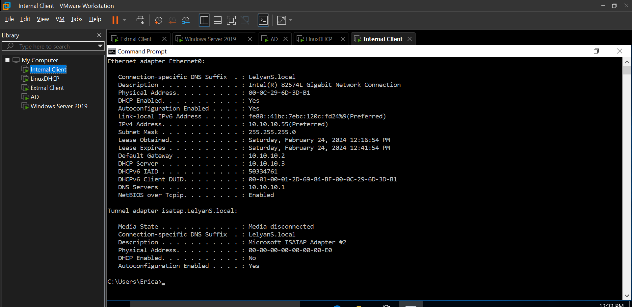

Accessing ftp.

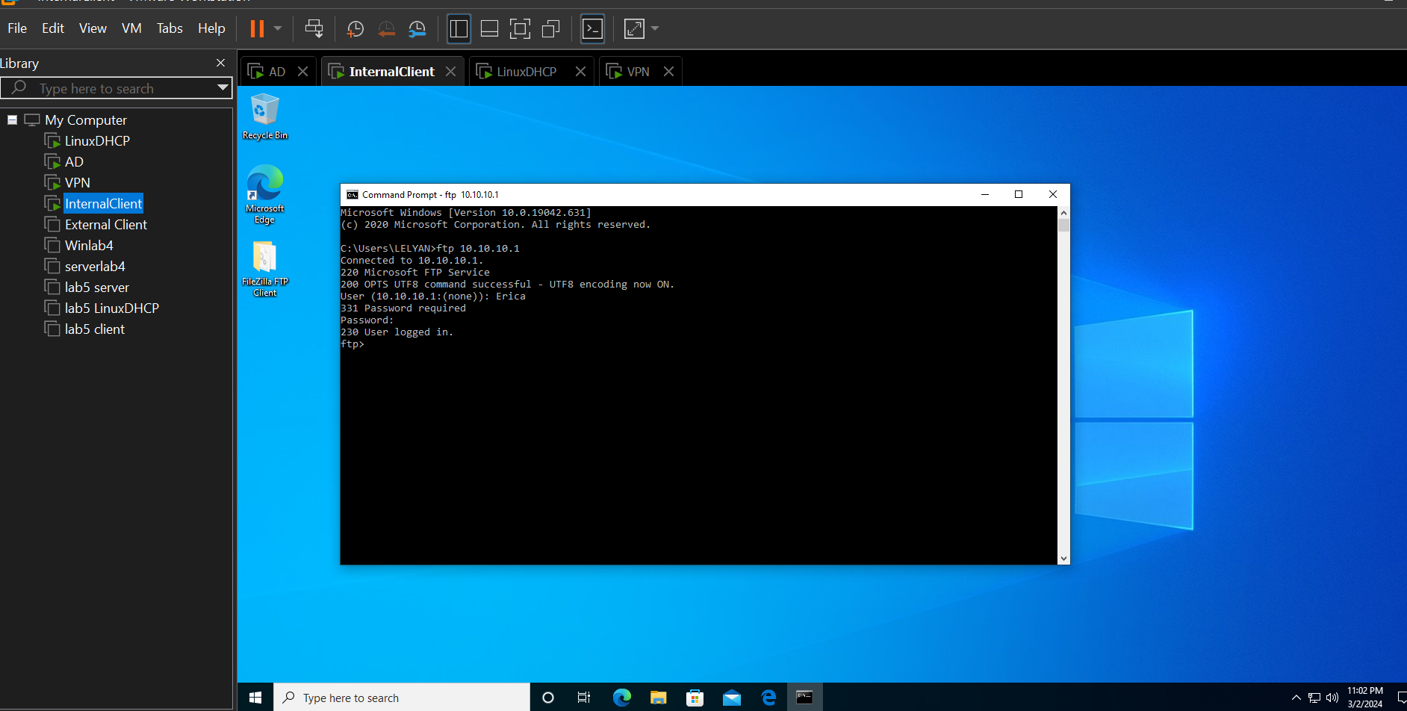

Being denied Accessing staff website

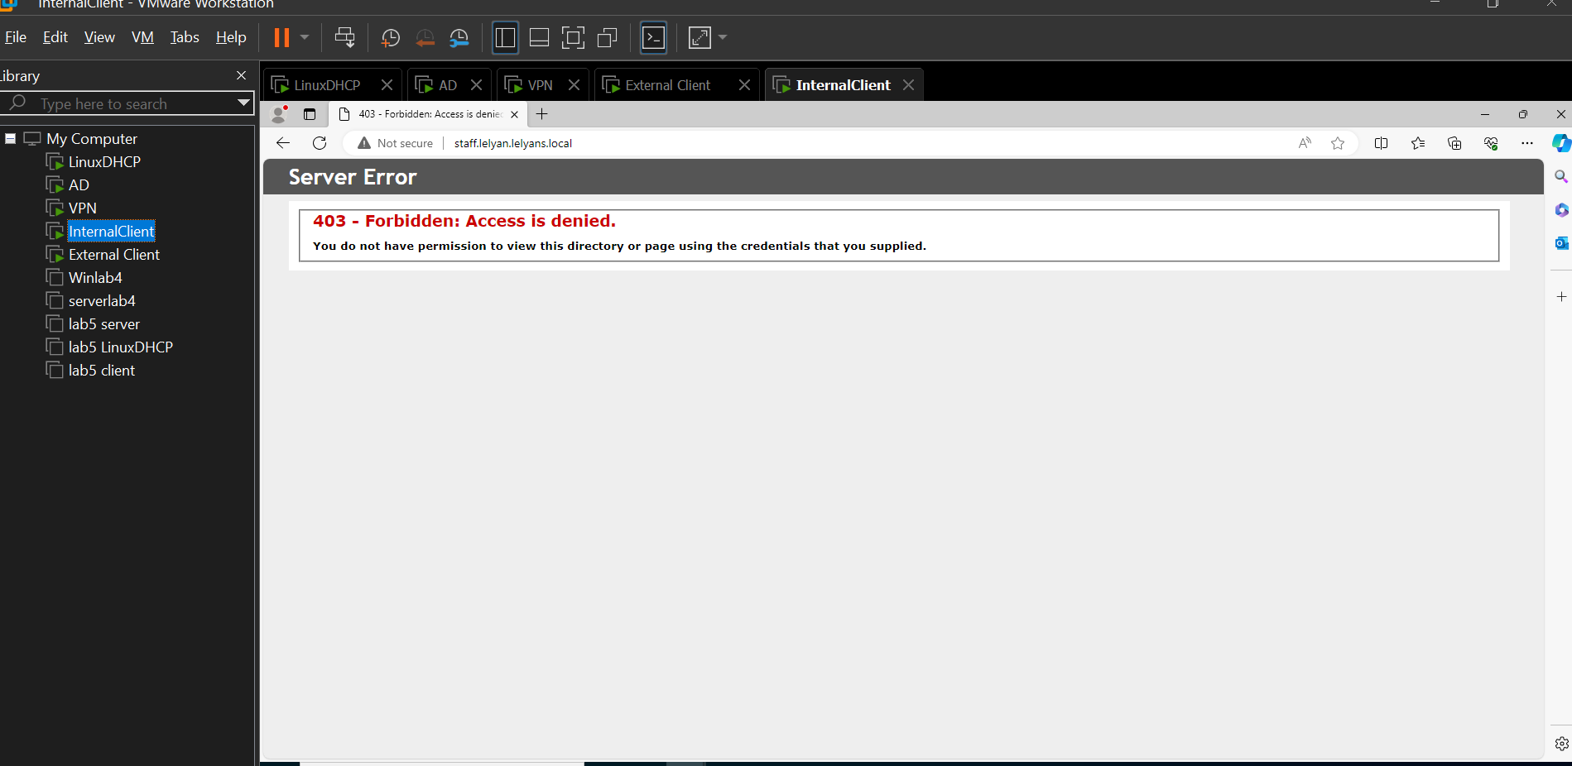

==When logged in as Trish==

Using browser to access staff website – including login prompt

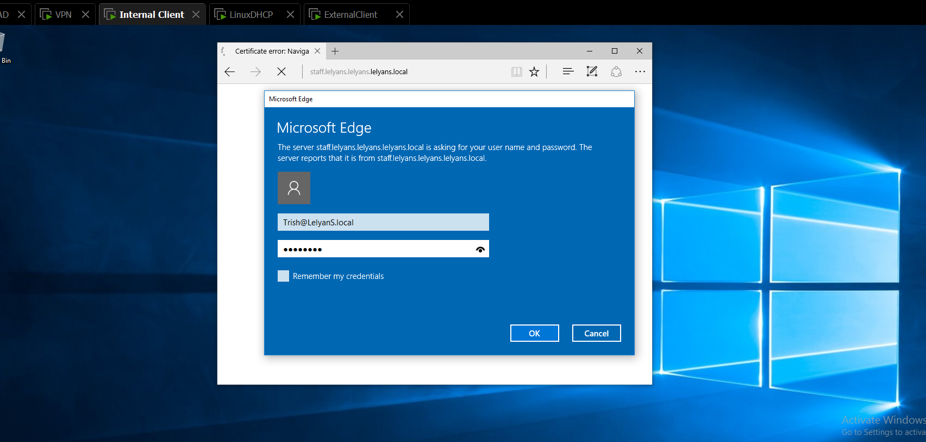

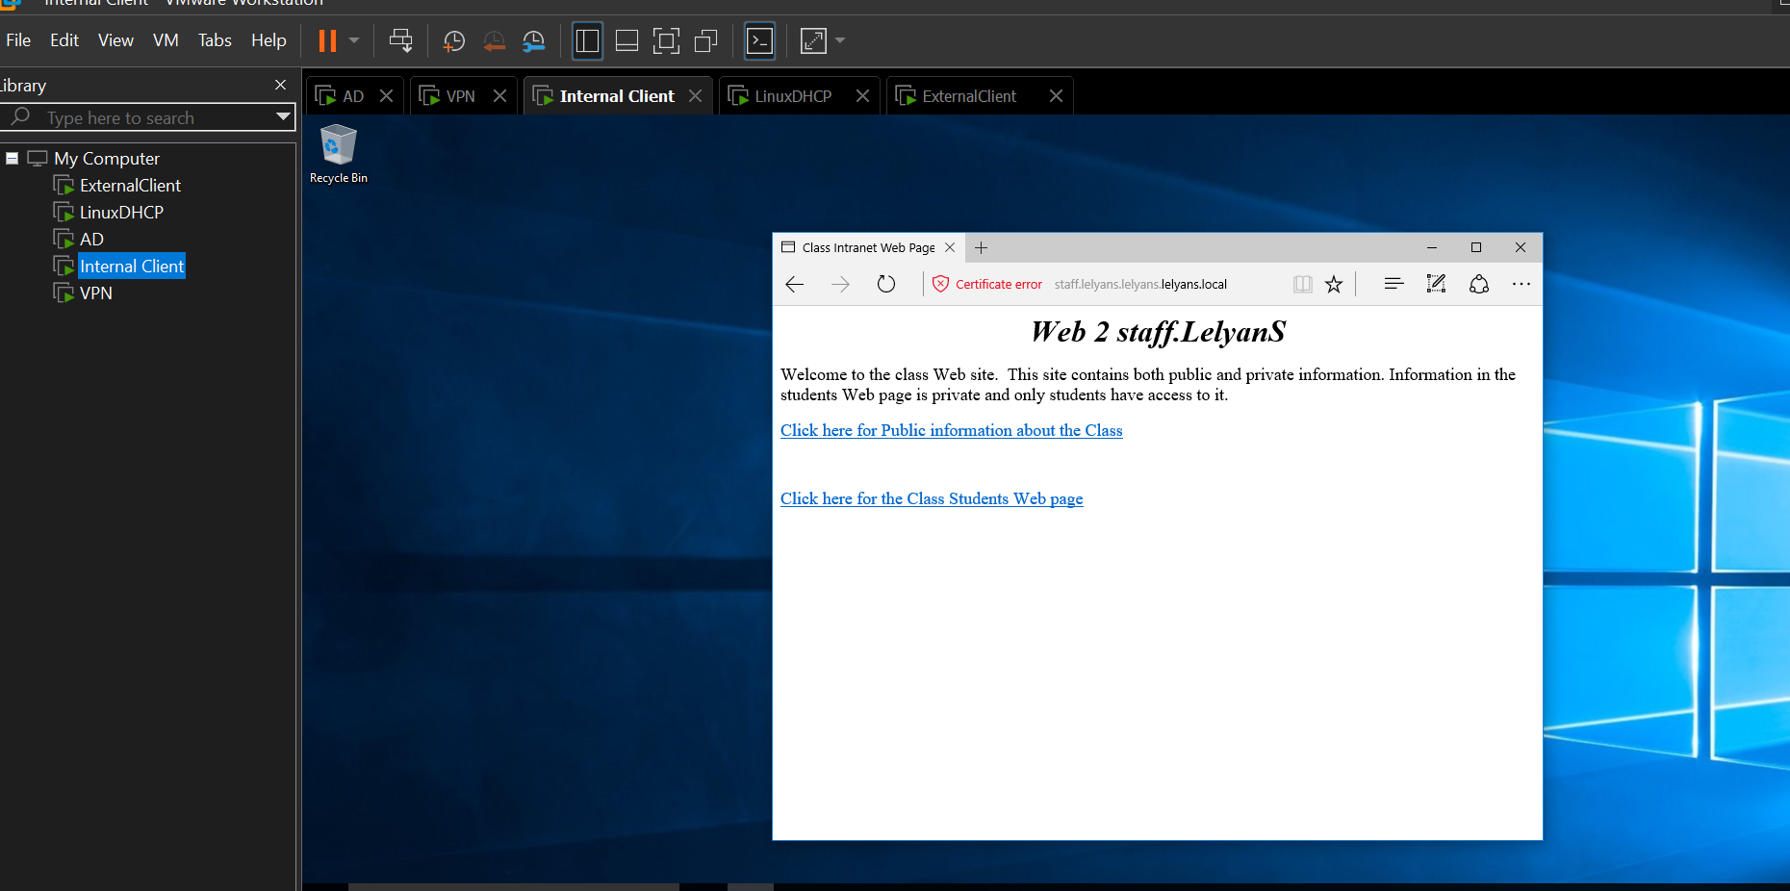

Successfully accessing www website – showing https:// connection

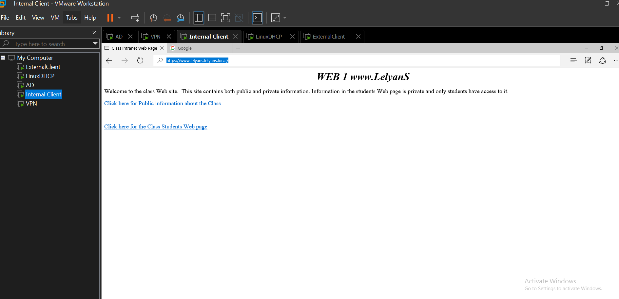

Able to access Internet site with browser

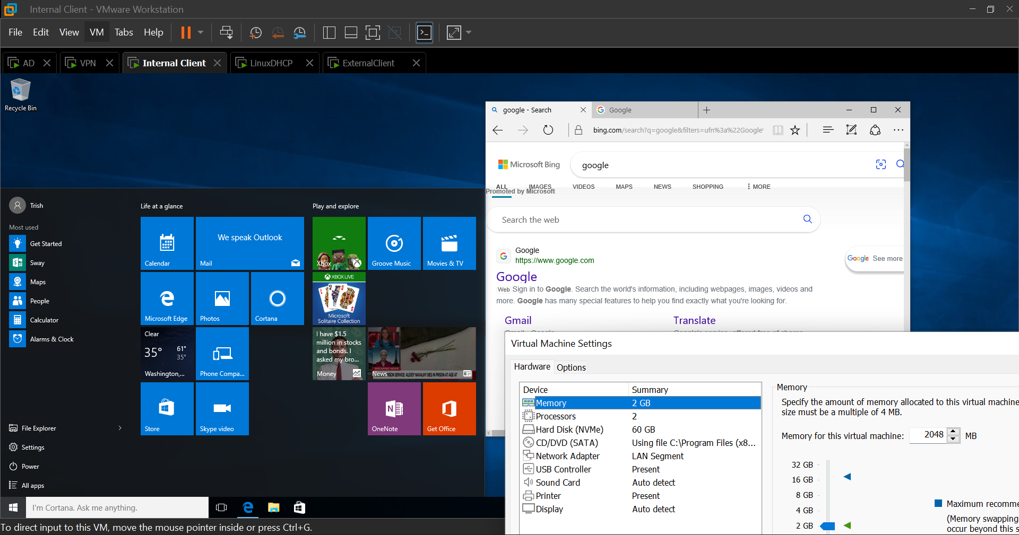

Writing to ftp site

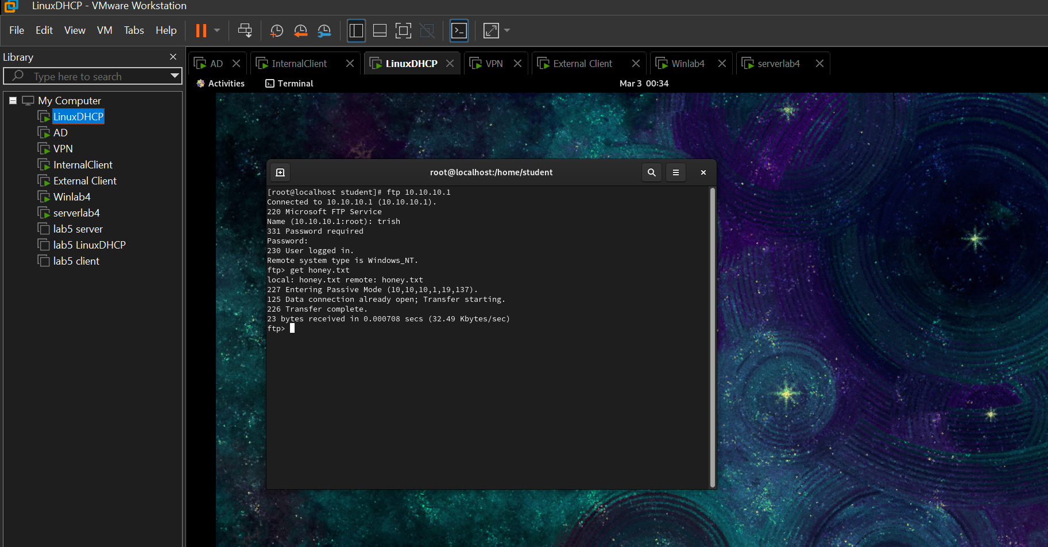

**External client**

==When logged in as Simon==

Successful VPN connection

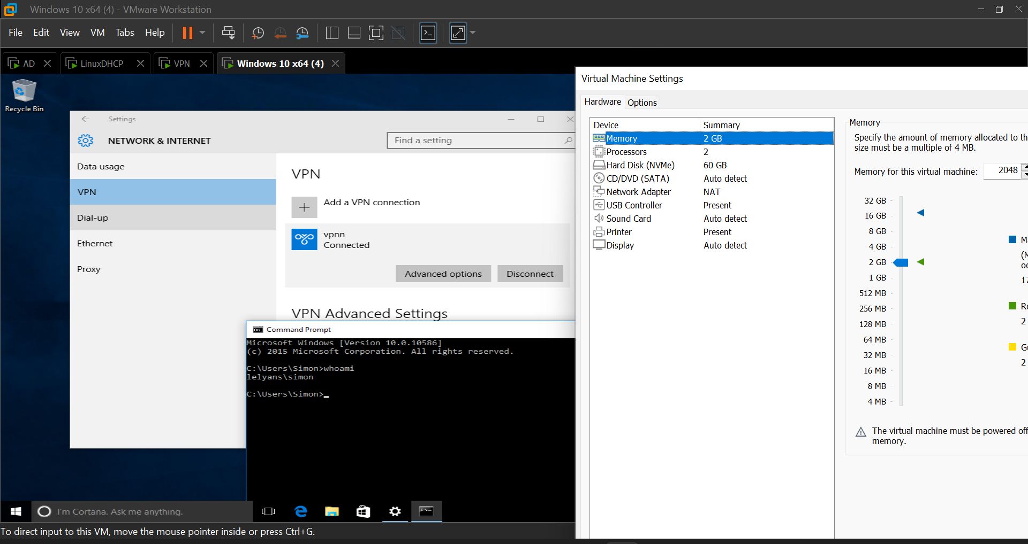

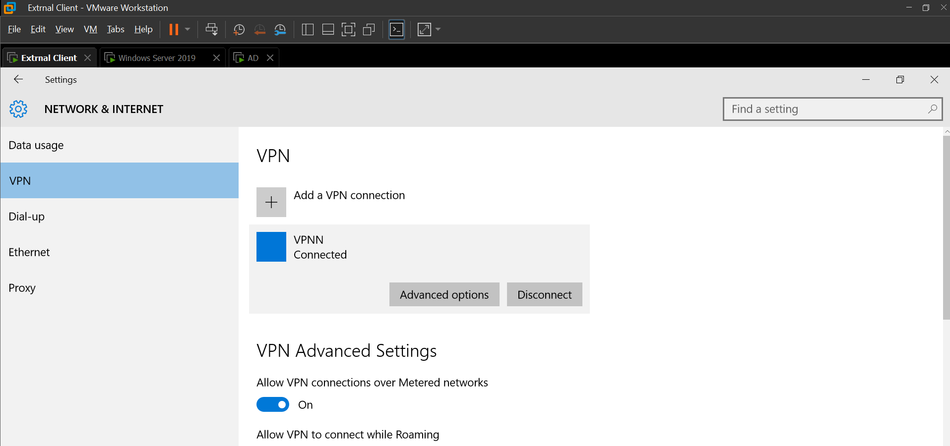

Ipconfig /all when VPN connected

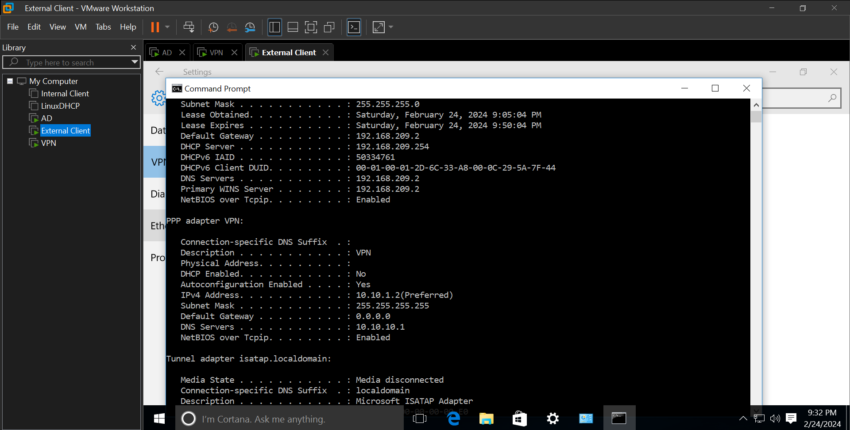

Accessing staff website

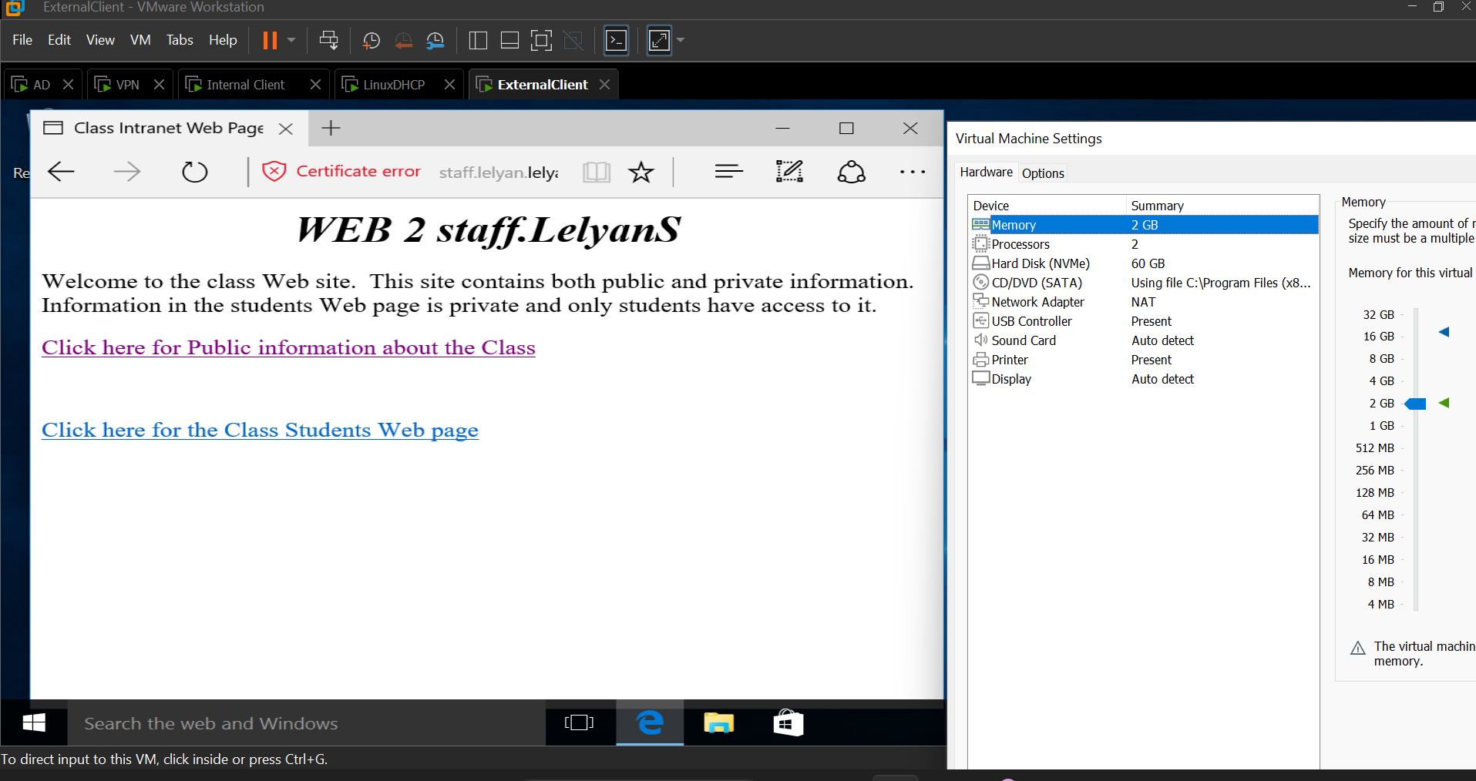

Accessing honey share, able to read but without being able to write to it

